**Guidelines for Data Visualization and Analysis Project**

**About the Project:**

In this project, you will be working with a dataset from the Superstore, aiming to answer 30 scenario-based questions through data visualisation and analysis. Your objective is to select the best chart for each question, explain your choice. This project will showcase your proficiency in data visualisation, critical thinking, and effective communication.

**Skills Required:**

* Proficiency in data visualisation concepts and techniques.
* Familiarity with Tableau or a similar data visualisation tool.
* Strong analytical and problem-solving skills.
* Ability to choose appropriate charts based on data characteristics and question requirements.
* Clear and concise communication skills.

**Deliverables:**

* A Google document containing solutions to the scenario based questions including the screenshot of relevant chart picked for each scenario, presented in a concise and well-structured format. Make sure to provide explanations that highlight your problem-solving skills.

**Rubrics for Assessment:**

Question Responses:

* Accuracy and completeness of answers for all 30 questions.
* Clear and concise explanations that address the question's context.

Chart Selection and Explanation:

* Thoughtful rationale for choosing specific chart types.
* Justification based on data characteristics, context, and communication goals.

Creative Enhancements:

* Effective use of creative elements to enhance visualisation quality.
* Enhancements that contribute to better understanding or engagement.

**Note**:

* Duplicate this document and proceed to write your solutions.
* For each scenario and question, provide a justification for the choice of chart type. Explain why it is the best option to visualise the data effectively.
* Attach screenshots of the charts you have created in Tableau for each scenario and question using the Superstore dataset. Label them clearly to match the corresponding questions in the Google Document.
* Submit the duplicated google doc file after completion.

Use these guidelines to structure your data visualisation and analysis project. Remember to maintain consistency in your responses, explanations, and visualisation styles. This project will not only demonstrate your skills but also your ability to effectively communicate complex information through visualisations. Good luck!

**Problem Statement: Choose the Best chart for any 30 scenario based questions from Superstore Dataset.**

Imagine you are a data enthusiast aiming to excel in data visualisation and analysis. In this task, you have been given any 30 scenario-based questions derived from the Superstore dataset, and your objective is to provide insightful answers using appropriate charts. For each question, you need to select a chart that best represents the data, explain why you chose that specific chart, and then proceed to build the chosen chart using Tableau.

Your responses should be succinct, organised, and illustrative of your problem-solving capabilities.

**Dataset Link:**

<https://community.tableau.com/s/question/0D54T00000CWeX8SAL/sample-superstore-sales-excelxls>

**Please keep in mind:**

1. **Answer Completion**: Ensure that you furnish answers for all any 30 questions and build charts for them.
2. **Encouraged Creativity**: Don't hesitate to employ visuals, creative elements, or any other innovative approaches to enhance the quality of your responses.

By completing this task effectively, you'll not only demonstrate your proficiency in data visualisation and analysis but also showcase your ability to effectively communicate complex concepts through both text and charts.

**Good luck!**

**Questions:**

1. Which product categories have the highest total sales in the "Superstore" dataset?

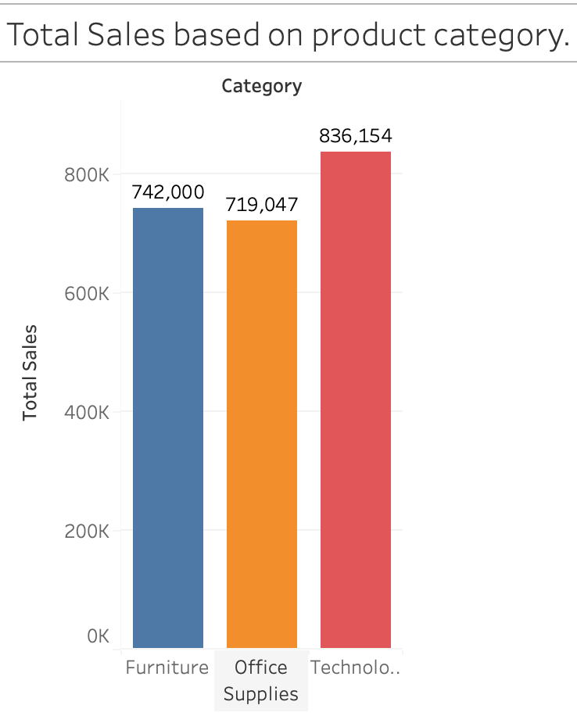

**Answer:** The Furniture product category has the highest total sales(742000) based on different-different category**.** Indicating the high customer demand, likely due to higher price points and business dependency on tech products.

**Reason for Choosing Column Chart:**

* A bar chart effectively compares total sales across different product categories, making it easy to visualize and interpret the data differences.

2. How do the monthly sales amounts change over the course of a year?

**Insights from the Bar Plot:**

* + **Sales Trend**: Sales initially increased from January to June before peaking in October (**204,727**) and November (**330,682**), showcasing a significant seasonal growth in the latter part of the year.
  + **Sales Decline**: February showed the lowest sales at **68,546**, highlighting a drop early in the year.
  + **Mid-Year Stability**: Sales remained relatively stable through mid-year, with values consistently around **140,000 to 160,000** from April to August.

**Reason for Choosing Bar Plot:**

* Clear Comparisons: A bar plot effectively visualizes the differences in sales across each month.
* Easy Interpretation: The horizontal format allows for straightforward reading and comparison of values.

1. How is the total sales amount distributed among different product categories?

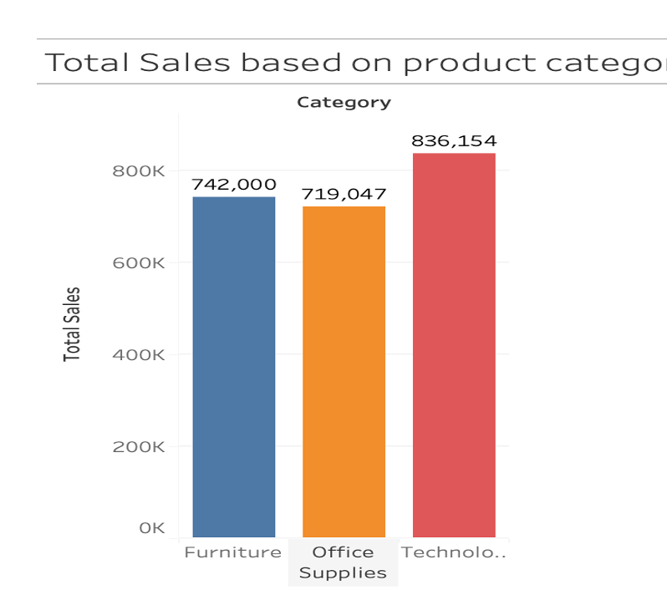

**Answer:**

* Highest Sales in Technology: The Technology category achieved the highest total sales, amounting to $836,154.
* Strong Performance in Furniture: Furniture sales follow closely behind, with total sales reaching $742,000, indicating a robust market segment.
* Office Supplies Lagging: The Office Supplies category has the lowest total sales at $719,047, suggesting potential areas for growth or a need for strategic improvement.
* Proximity in Sales Figures: The sales figures for Furniture and Office Supplies are relatively close, with only a difference of $22,953 between them, highlighting a competitive market.
* Overall Sales Observation: The cumulative total sales across all three categories reflect a healthy performance, with total sales exceeding $2.3million collectively.

**Reason for Choosing Column Plot:** The column chart effectively illustrates the total sales across different- different product categories, highlighting variations and trends for informed decision-making.

4. Can we analyse the sales performance of individual customers over time?

**Answer**: Yes, we can analyse the sales performance of individual customers over time by using various types of visualizations. Among these, the **line chart** is one of the best options for showing changes and trends over time. So, let’s visualize the sales performance of individual customers using a line chart to gain insights into their purchasing behaviour and sales trends.

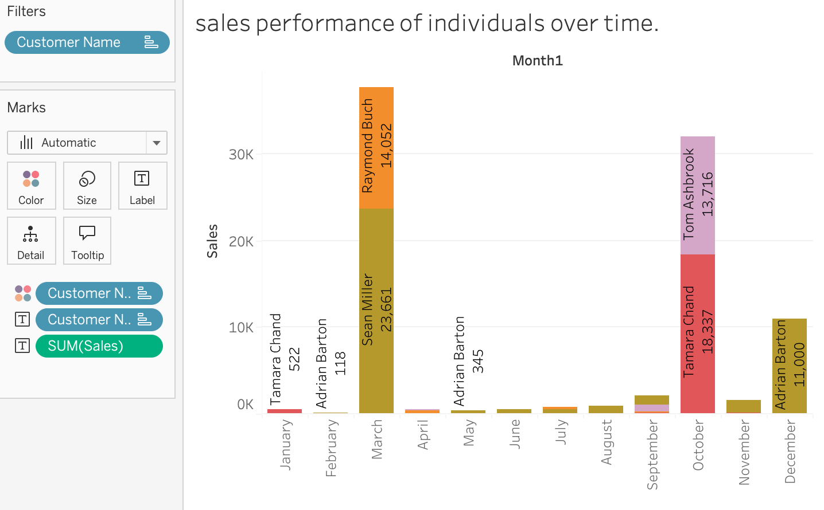

**Reason for choosing column chart:** The column chart is an effective way to represent values over time, making it ideal for our needs. In this case, we aim to visualize the total sales performance of individuals over a specific period.

5. How do sales vary based on different days of the week and product categories?

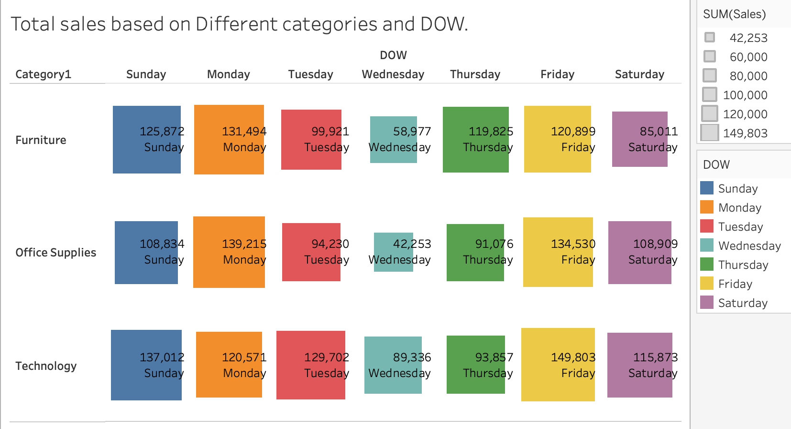

**Answer:**

**Sales Categories:** Displays total sales in three categories: Furniture, Office Supplies, and Technology.

**Days of the Week (DOW):** Presents sales data across seven days: Sunday to Saturday.

**Sales Values:** Numerical values in the cells represent total sales for each category on each day.

* **Key Insights:**

**Peak Sales:** Technology had the highest sales on Friday (149,803), making it the top-performing category.

**Friday** is also promising, particularly for Technology.

**Lowest Sales:** Office Supplies had the lowest sales on Wednesday (42,253), indicating potential need for marketing strategies on this day.

**Consistent Performers:** Both Furniture and Technology show consistently high sales on Monday, indicating a strong start to the week.

**Reasons for Choosing Heatmap Chart:** It effectively visualizes complex data, making it easier to comprehend sales performance at glance.

6. Can we visualise the sales growth of different product categories over time?

**Answer:** Yes, we can visualise the sales growth of different-different product category over the time.

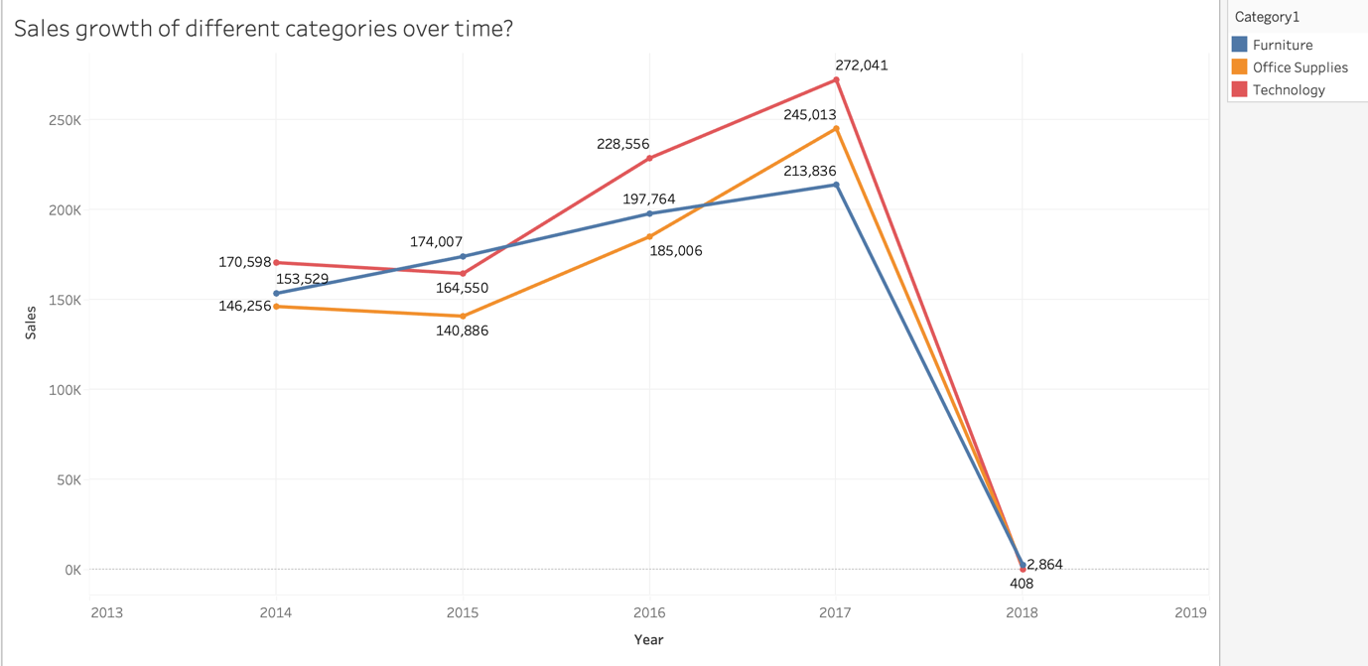

**Overall Growth:**

* All categories increased sales from 2013/14 to 2017/18.
* Example: The highest-performing category grew from roughly 400 in 2013/14 to about 700 in 2017/18.

**Variable Performance:**

* Categories have different starting and ending sales values.
* Example: In 2015/16, the sales range spanned from approximately 250 (lowest category) to 600 (highest category).
* Growth rates also vary: Some lines are steeper than others.

**Growth Spurts/Lags:**

* Specific years show rapid or slow sales changes.
* Example: The middle category showed a significant increase between 2014/15 and 2015/16 (a steep upward slope).
* Example: The lowest category's growth appears to slow down after 2016/17.

**Convergence/Divergence:**

* Sales gaps between categories change over time.
* Example: Initially, in 2013/14, the gap between the top and middle categories was smaller than the gap in 2017/18, suggesting divergence.

**Trend-Based Projections:**

* Recent trends indicate potential future sales.
* Example: If the highest category maintains its current trend, it could exceed 750 in the next period.
* Example: The lowest category's trend suggests potentially slower growth compared to other categories.

**Reasons for Choosing Line Chart:** Line charts are ideal for visualizing sales growth over time because they clearly show trends and changes in continuous data, making it easy to compare the performance of different product categories simultaneously across the years.

7. How does the sales distribution vary across different regions in the "Superstore" dataset?

**Visualization:**

**Insights:**

* As we can see in the chart the West region leads the sales and having the most number of sales(7,25,458), it means people from west region they prefer to buy all the products which are offered in the product category.
* After West, East region holds the second most number of sales which is total(6,78,781).
* The Central region's sales (501,240) fall in the middle, suggesting moderate sales activity compared to the top two regions.
* Now when we talk about the less number of sales then South region is at last potion in terms of total sales, it has least total sales(3,91,722).
* **Sales Disparity:** There's a noticeable difference in sales performance across regions. The West's sales are significantly higher than the South's, highlighting an uneven distribution of sales.

**Reasons for Choosing column Chart:** Given the four categorical regions in our dataset, a column chart provides the optimal visualization for comparing their respective total sales.

8. Can we visualise the composition of profits across various subcategories within different customer segments?

**Answer:** We can visualize the composition across various subcategories within different customer segments effectively using Tableau. To achieve this, we will place the **Sub-Category** field on the **X-axis** and the **Total Profit** on the **Y-axis**. Customer **Segments** will be distinguished using the **Color** mark, allowing each segment to be visually differentiated across the subcategories. This approach will clearly highlight the distribution of profits among subcategories for each customer segment, making it easier to identify trends, opportunities, and areas for improvement.

**Visualization:**

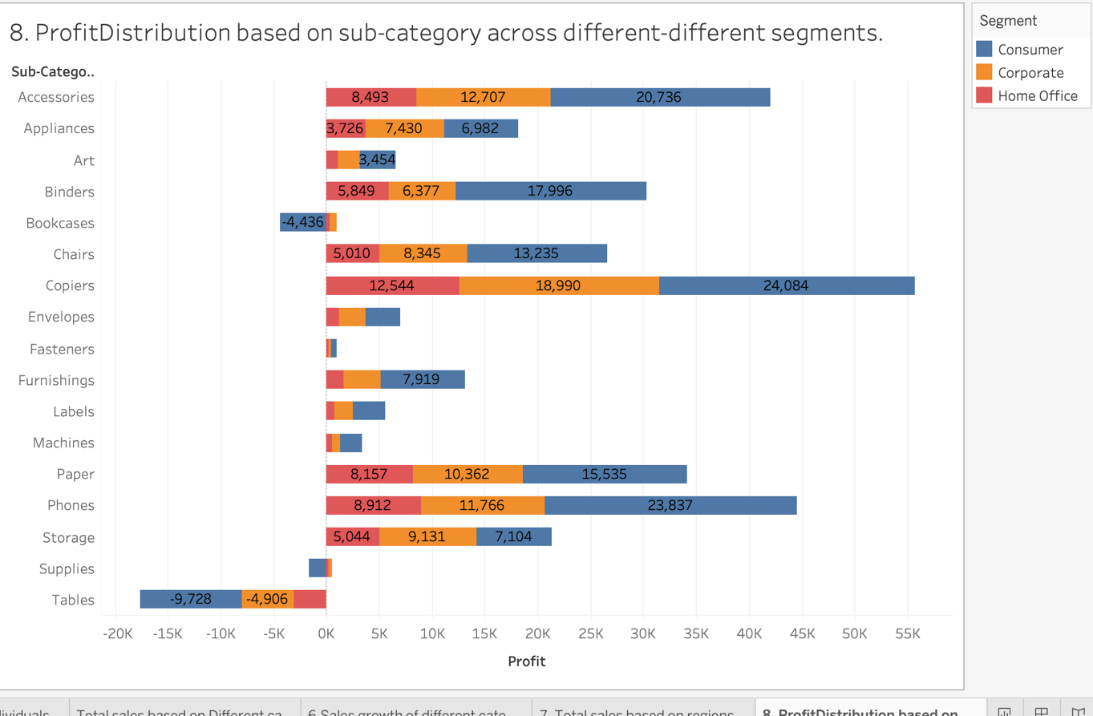

**Insights:**

* **Copiers Drive Significant Profit:** The "Copiers" sub-category generates the highest overall profit, with a substantial contribution from all three customer segments (Consumer, Corporate, and Home Office).
* **Tables Incur Losses Across All Segments:** The "Tables" sub-category consistently shows negative profit (losses) across all customer segments, indicating a significant area of concern.
* **Technology Sub-categories are Highly Profitable:** "Copiers" and "Phones" (both likely within the Technology category) show the highest profit margins, suggesting this product area is a key profit driver.
* **Consumer Segment Often Dominates Profit:** For many sub-categories (e.g., Accessories, Binders, Chairs, Paper, Phones, Storage), the "Consumer" segment contributes the largest share of the profit compared to the "Corporate" and "Home Office" segments.

**Varying Segment Contribution by Sub-category:** The profit contribution of each customer segment varies significantly depending on the sub-category. For example, "Appliances" see a more balanced contribution from all segments, while "Bookcases" profit is primarily driven by the "Corporate" segment.

**Reasons for Choosing column Chart:** A bar plot is suitable here because it effectively displays the profit contribution of different customer segments (categorical data) for each sub-category, allowing for easy comparison of profit amounts and segment composition within each sub-category. The stacked format further enables visualization of the total profit and the relative contribution of each segment to that total.

9. What is the percentage contribution of each region to the overall sales?

**Visualization:**

**Insights:**

* **Highest Contribution:** The **West region** contributes the largest share at **31.58%** of overall sales.
* **Significant Contributions:** Following the West, the **East region** has a substantial share of **29.55%**, making it the second-largest contributor.
* **Moderate Contribution:** The **Central region** accounts for **21.82%**, placing it in the mid-range of contributions among the regions.
* **Lowest Contribution:** The **South region** shows the smallest contribution at **17.05%**, indicating it has the least impact on overall sales.
* **Overall Distribution:** The combined contribution of the West and East regions (approximately **61.13%**) suggests a strong performance from these areas compared to the Central and South regions.

**Reason for the Pie Chart:** The pie chart is the best way to represent the percentage contribution of each categorical value in any variable, which is why we use a pie chart.

10. Can we visualise the profit margins associated with different shipping modes and customer segments?

**Answer:** We can visualize the total profit margins associated with different shipping modes and customer segments.

**X-axis:** Total profit margin

**Y-axis:** Types of ship modes

**Colour Representation:** Different customer segments

The bar chart illustrates the distribution of total profit margins for each shipping mode, segmented by customer type.

**Visualization:**

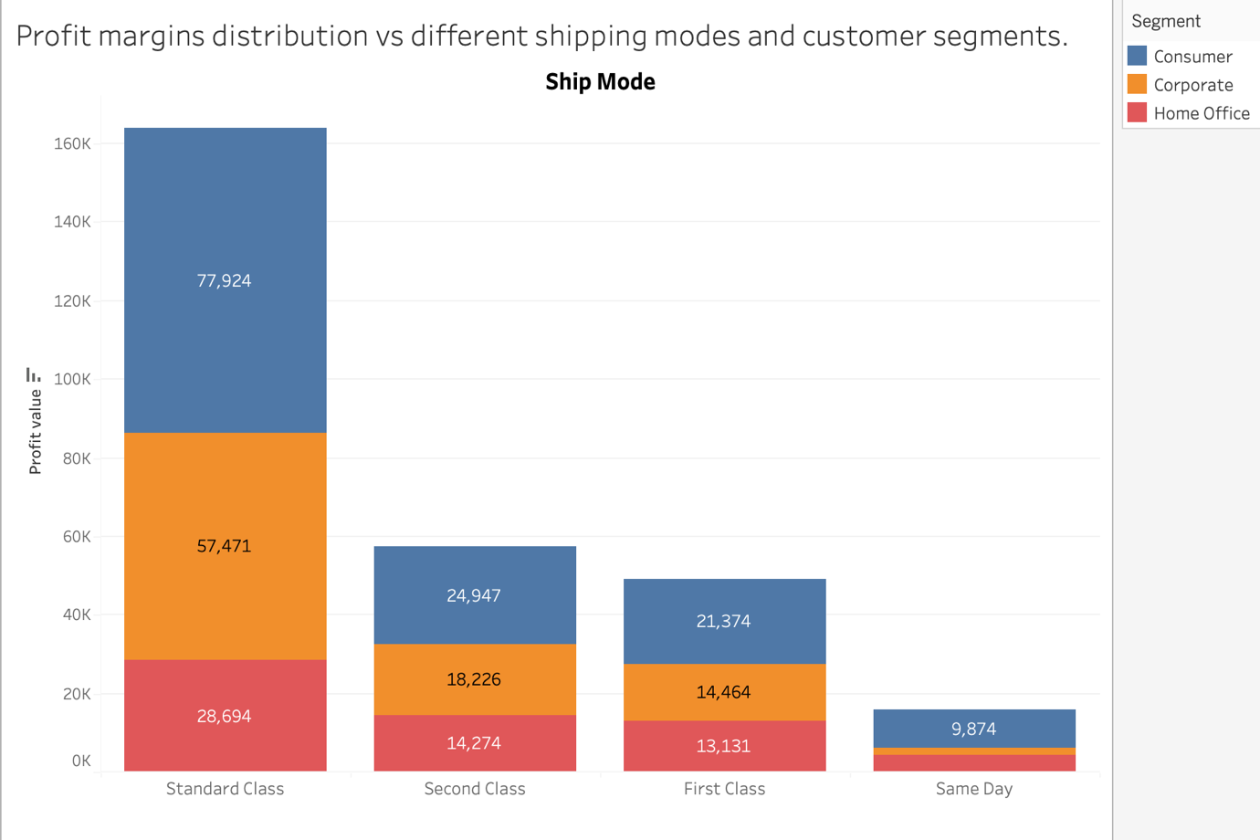

**Insights:**

* Highest Profit Margin: Standard Class: The Standard Class shipping mode shows the highest profit margin, with a total of **77,924**.
* Significant Difference from Other Modes: There is a notable difference in profit margins between Standard Class and other shipping modes like Second Class (**24,947**) and First Class (**21,374**).
* Second Class vs. First Class: Second Class has a slightly higher profit margin than First Class, with **24,947** versus **21,374**, indicating that it could be a more cost-effective choice.
* Low Profit for Same Day Shipping: Same Day shipping has the lowest profit margin among all modes, reflecting its limited profitability compared to others.
* Revenue Distribution Insights: Within each shipping mode, there's a clear distribution of profit margins across different customer segments, suggesting a diverse customer base with varying preferences for shipping speed and cost.

**Reason for the Column Chart:**

* Clearly displays profit margins across shipping modes (Standard Class, Second Class, First Class, Same Day).
* Colours represent various customer segments for easy distinction and analysis of their contributions.
* Vertical bars highlight the scale of profit margins, showing which modes are most profitable.
* Combines data categories, facilitating analysis of relationships between shipping modes and customer segments.

11. How long does it take to process orders for different product categories?

**Answer:**

* **Furniture** takes about **24.1 days** to ship after ordering.
* **Office Supplies** takes about **22.3 days**.
* **Technology** takes about **22.1 days**.

Thus, **Furniture** has the **longest processing time**, while **Technology** has the **fastest** among the three product categories.

Visualization:

**Insights:**

* Technology ships fastest: Technology items are smaller and standardized, leading to quicker processing.
* Office Supplies are in between: Shipping times are moderate, suggesting average handling complexity.
* Small but important difference: The 2-day gap can still affect customer satisfaction, especially at scale.
* **Improvement focus:** Streamlining Furniture logistics could help reduce processing time and boost competitiveness.

12. How do discounts affect overall profit?

**Answer:**

* **Higher discounts usually lead to lower profit:** Categories with bigger discounts tend to earn less profit on average.
* **Technology is the most profitable category:** Even with higher discounts, it brings in the highest average profit, likely due to better margins.
* **Furniture performs poorly:** It has high discounts but very low profit, which may indicate over-discounting.
* **Office Supplies stay profitable without big discounts:** This category offers almost no discounts but still earns decent profit.
* **More sales doesn’t always mean more profit:** Some categories sell more but still earn less profit overall.

**Visualization:**

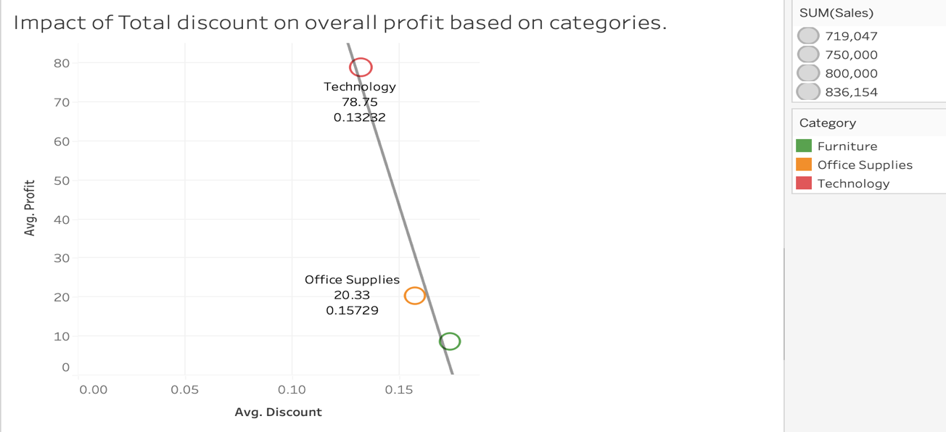

13. Can we visualise the relationship between product sales and profitability for different product categories?

**Answer:** To visualize the data, we first placed 'Category' on the x-axis and both Average Sales and Average Profit on the y-axis. The default visualization was a bubble chart, which wasn't effective for conveying the desired story. We therefore changed the chart type to a side-by-side bar chart for better representation. This allows us to clearly see and compare both the average sales and average profit values for each category.

**Visualization:**

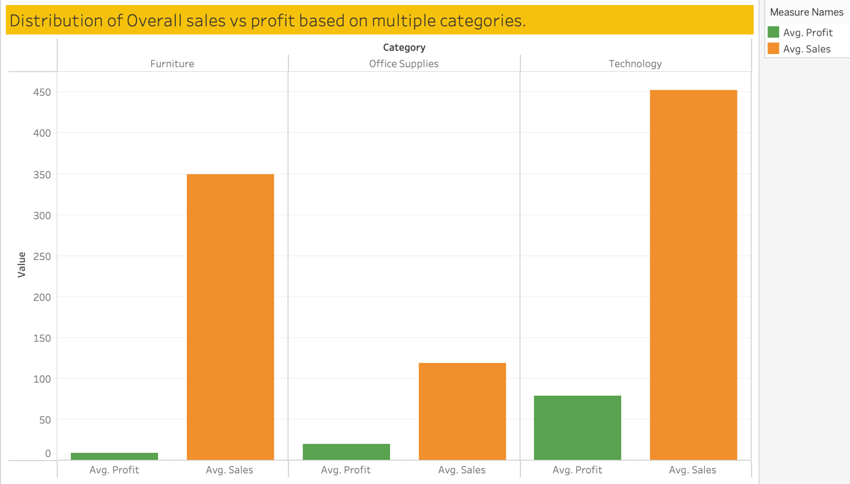

**Insights:**

• **Highest Sales Performance:** The Technology category shows the highest average sales. Its sales value significantly surpasses both Furniture and Office Supplies.

• **Top Profit Generator:** Technology also leads in average profit. This category achieves the highest average profit margin among the three.

• **Furniture's Profit Challenge:** Furniture exhibits the lowest average profit. Despite having the second-highest average sales, its profitability is minimal.

• **Office Supplies Balance:** Office Supplies demonstrate modest average sales and profit. This category ranks lowest in average sales but outperforms Furniture in average profit.

• **Sales vs. Profit Disparity:** There isn't a direct correlation between high sales and high profit across all categories

**Reason for this chart**: We selected a side-by-side column chart to show the distribution of sales and profit margins across different categories. Column charts are suitable for displaying distributions for categorical variables, and the side-by-side format allows for comparing multiple measures (sales and profit margin) for each category.

14. What is the distribution of order quantities for products in the dataset?

**Visualization:**

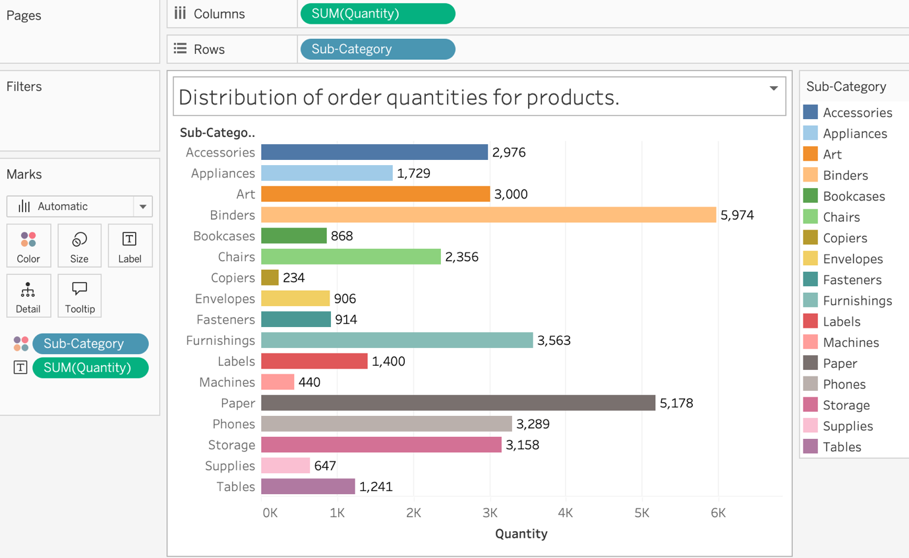

**Insights:**

**1. Leading Sub-Category:** Binders emerged as the top-selling product, with a substantial quantity of 5,974 ordered. This indicates a strong demand for binders compared to other product categories.

**2. Art and Furnishings:** The Art sub-category follows closely with 3,000 units sold, highlighting its popularity. Furnishings also show significant orders at 3,563, reflecting a robust interest in office-related décor.

**3. Low Performers:** Copiers demonstrated the lowest order quantity at just 234 units, which may indicate a decline in demand. Machines also had a relatively low performance with only 440 units ordered, suggesting potential overstock or lower interest.

**4. Moderate Sales:** Several categories like Labels (1,400) and Supplies (647) achieved moderate sales figures. This suggests stable but non-exceptional interest in these sub-categories.

**5. Variation in Demand:** Overall, there is a wide variation in demand across sub-categories, with some like Tables (1,241) showing decent sales, while others lag significantly.

**Reason for this chart**: This horizontal bar chart clearly compares order quantities across 17 sub-categories, making it ideal for analysing product demand.

15. How do the profit distributions vary across different product categories?

**Visualization:**

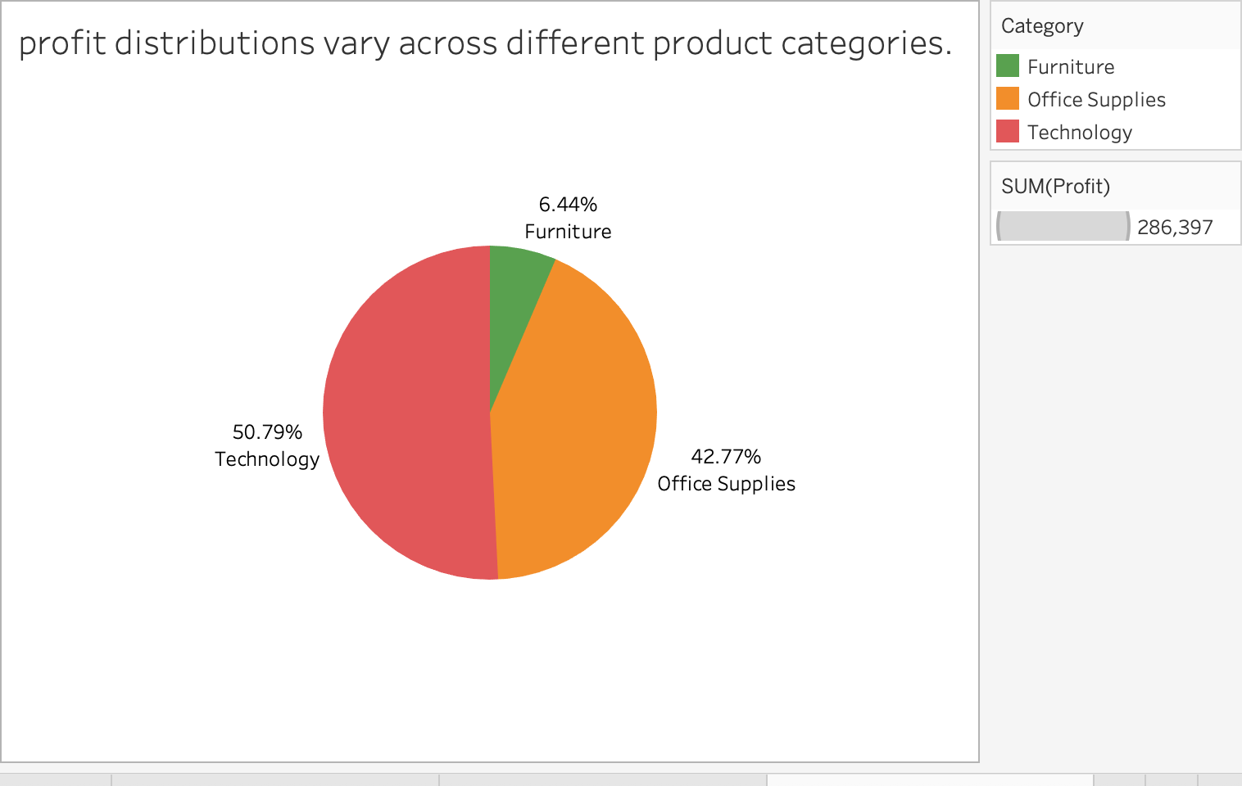

**Insights:**

* **Dominant Category**: **Technology** accounts for the largest share of profits at **50.79%**.
* **Significant Contribution**: **Office Supplies** is the second largest category, contributing **42.77%** to the total profits.
* **Minimal Share**: **Furniture** has the smallest representation, making up only **6.44%** of the total profit.
* **Total Profit Summary:** The overall sum of profits across all categories is **$286,397**.
* **Imbalance in Profit Distribution**: There is a notable disparity in profit distribution among the categories, with Technology and Office Supplies together accounting for over **93%** of total profits, indicating a potential focus for business strategy on these categories.

**Reason for this chart type:**

* To compare proportional profit contributions: The pie chart clearly shows how much each product category contributes to the overall profit.
* **T**o identify high and low-performing categories: It instantly highlights that Technology is the top contributor (50.79%), while Furniture lags (6.44%).

16. Can we compare the shipping time distributions for different shipping modes?

**Answer:** This chart compares shipping times across different shipping modes. To create it, we first calculated the time difference in hours between the 'Order Date' and 'Shipping Date' using a Tableau calculated field named hour_between_delivery (using the DATEDIFF('hour', [Order Date], [Ship Date]) function). We then plotted the [Average/Median - specify if known] hour_between_delivery on the y-axis against 'Shipping Mode' on the x-axis. Each shipping mode is distinguished by colour and labels show the specific time difference for each mode.

**Visualization:**

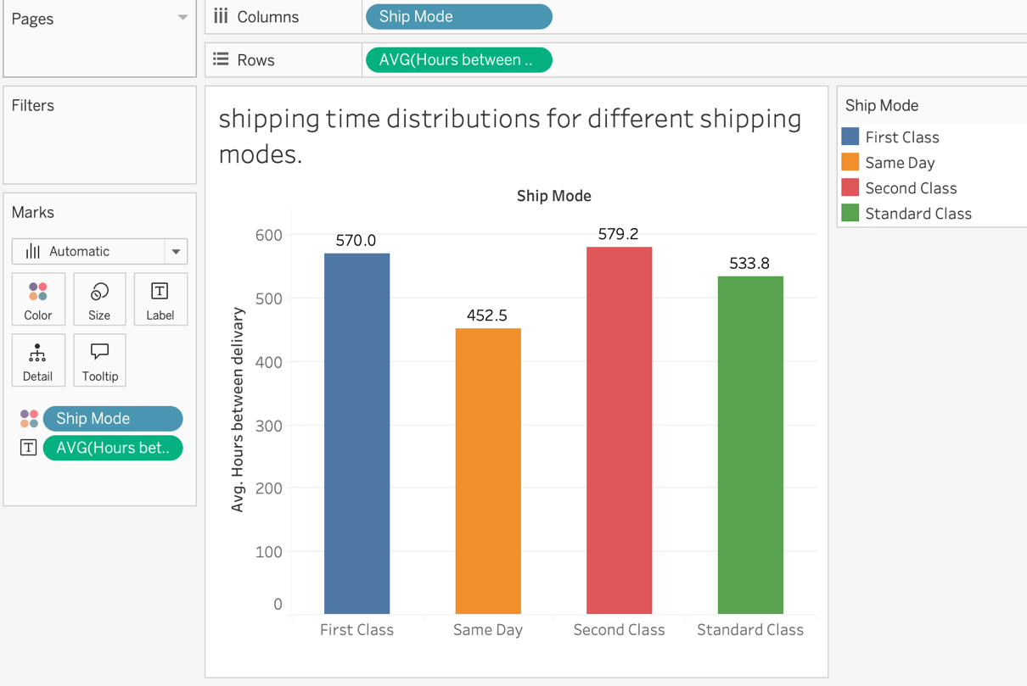

**Insights:**

* **Same Day shipping is the fastest**: It has the lowest average delivery time of approximately **452.5 hours**, which makes it the most efficient option in terms of delivery speed.
* **Second Class is the slowest shipping mode**: With an average delivery time of about **579.2 hours**, Second Class takes the longest among the four shipping options.
* **First Class is not the fastest**: Despite the name, **First Class averages 570 hours**, which is significantly slower than Same Day and even slower than Standard Class.
* **Standard Class performs better than First and Second Class**: At **533.8 hours**, Standard Class ships faster than both First Class and Second Class, making it a better choice than the name might suggest.
* **Naming does not reflect actual performance**: The chart highlights a mismatch between shipping mode names and their actual delivery times, especially with “First Class” and “Second Class” performing worse than “Standard” and “Same Day”.

17. What is the monthly trend in the number of orders shipped?